# NuGet Setup

1. Tools > Add-In Manager  
   
2. Gallery > Repository Dropdown > Manage Repositories…  
   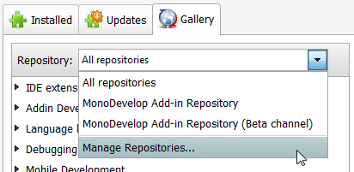
3. Add  
   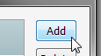
4. In the **Register an on-line repository** option, add the following to the **Url**:   
   <http://mrward.github.com/monodevelop-nuget-addin-repository/4.0/main.mrep>  
   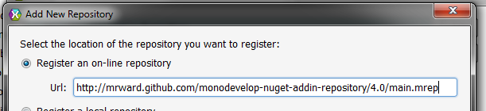
5. Select **OK**
6. On the **Gallery** tab, expand the **IDE Extensions** node and select **NuGet Package Management**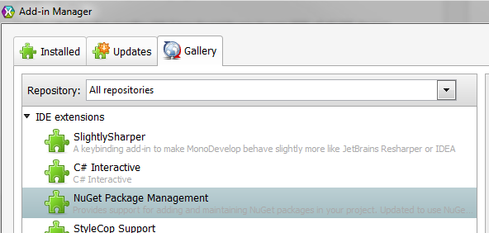
7. Select the **Install...** option  
   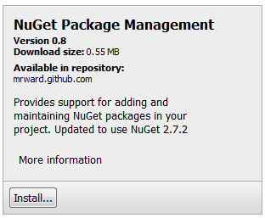
8. Select **Install**  
   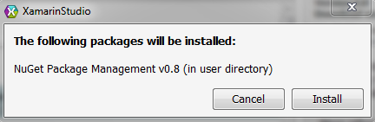
9. You now have NuGet Support in Xamarin Studio!

# NuGet Reference Setup

1. Right-Click **References** and select **Manage NuGet Packages…**  
   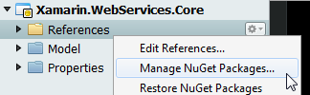
2. In the search bar on the right, type in **microsoft.net.http** and click the search button  
   
3. In the results pane, select the **Microsoft HTTP Client Libraries** item  
   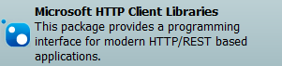
4. Click the **Add** button  
   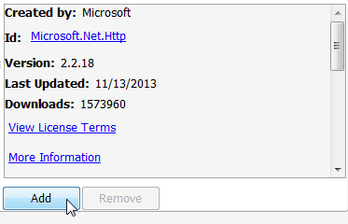
5. On the **License Agreements** screen, select **OK**  
   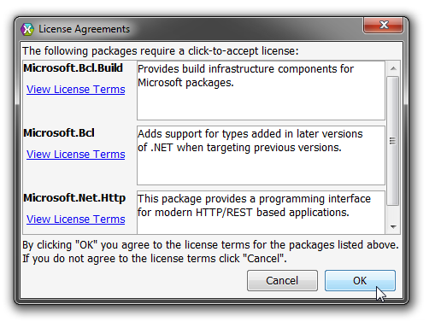
6. In the search bar on the right, type in **json.net** and select the search button  
   
7. In the results pane, select the **Json.NET** item  
   
8. Click the **Add** button  
   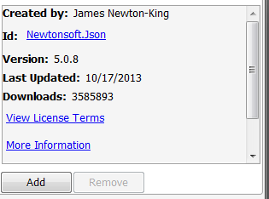
9. **Close**

# Rest Client

1. Right-Click the **Client** folder and select **Add > New File…**
2. Name the class **RestClient** and select **New**  
   